David Muh (穆椿榮, 2 ban)  April 20, 2010 | 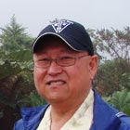
Dear CKHS classmates,

It was indeed a great reunion that Houston classmates organized for the weeklong Costa Rica tour. I particularly appreciated that our entire classmates did not ignore my youngest son’s participation. As such, he, Patrick, told me that he understood in great depth of my adolescent life in Taipei with all of you even though it was not always pretty! He also expressed envy of our life style that kept us bond together as glue for life time. Regardless to say, I also am proud of my son’s decision to come with me for the reunion. After we arrived at home, Patrick expressed many times that he would come again for our future reunion. My hat off to the Houston classmates that sponsored such an unforgettable reunion! Many thanks for their detailed preparation, hard work, and dedicated services.

During the farewell dinner party, I was asked to speak the regrets that I had for not coming to the reunion at Hawaii, 2008. I realized that our reunion is not just a scenery tour or a series of gourmet dinners at fancy restaurant, but enjoy our pastime unforgettable memories and mischievous meaningless actions and renew our friendship. Our in-depth pleasure is from our emotion and friendship that we built through the high school years in Taiwan. Read from the e-mail track from Hawaii reunion, I found that I missed such a wonderful feelings and felt lost in the nowhere land. And I knew then that I made a mistake for not participate the reunion. As I said at the party, I will try hard to attend every reunion as I physically can from now on.

One of our classmates indicated that many of us have great achievements in our life and some of them may not so lucky for their goals, but as long as we bond as CKHS classmates, these are not important anymore. Friendship exists whether in rich or in poor. I would like to see all of our classmates come for the next reunion in Taipei.

Patrick and I enjoy every minute of this trip. He also learnt that I came from the best high school in Taipei, but the worst class in our grade! That was his false impression. Many of our classmates from my class are honest, good students and are very successful in their career. I was just a kid at that time that had full of energy that spent into a wrong direction sometimes. He, however, do admire our close bonding friendship though.

I had opportunity to sing Peking Opera on the bus. I prepared a CD of 平劇伴唱. What a treat! Please it is my ultimate hobby and enjoys singing very much. I do not dare to show off but please you all, it is my humble contribution to the entertainment for the occasion. It is also my pardon if some of you dislike Peking Opera and felt offended. In total, I sang 3 segment of Peking opera: 洪羊洞 (二黃原板), 洪羊洞 (二黃慢板), and 狀元譜 (西皮原板).

Much to my surprise, I am not the only classmates located in Florida other than Yen Hwang (顏晃, 3 ban) in Orlando; I met Chau J. Hwa (華超君, 7 ban) whom he resides in West Palm Beach. I am at Melbourne/Palm Bay, which is at the East of Orlando and North of West Palm Beach, that forms a triangle that covers South-East part of Florida. After all, we are not the rare CKHS alumni species in Florida anymore.
``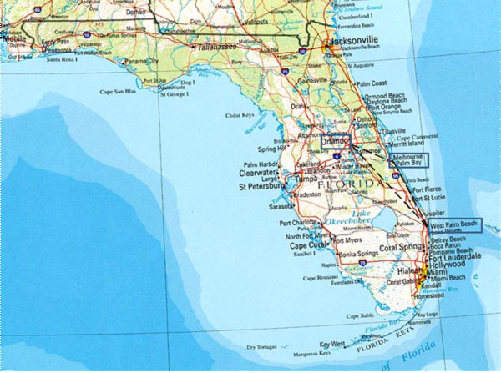
The biggest surprise was that I met my Shanghai elementary school classmate. In 1949, when my father retreat with government official to Taiwan, the rest of my family was left behind in Shanghai. During this very difficult year, I went to an elementary school where my uncle was a teacher there. That school was江灣區小學 while I was enrolled and finished first grade before my family left Shanghai in the summer of 1950. Our classmate Clark C. K. Liu (劉成均, 10 ban) was also in the same school from his 3rd grade until his graduation from 江灣elementary School. Although we did not meet each other at school, but we shared same memory of this school. We also exchanged our saga of escape from the communist occupation territory to Taiwan. Clark and I are both in compiling our exodus experiences following reading from 大江大海一九四九by 龍應台. I am sure that Clark and I were not the only two who experiences this great migration of the century, but we decided to document our memories for our children to read. We vowed to exchange our writings.

So rich memories that our classmates bought back from this trip, I can hardly calm down and do my work at the office this week. Thank you all for bringing back our happiness and fond memories. I shall see you all in Taipei for the next reunion!

