Our Cruise On Queen Victoria
6/22/2014 to 7/6/2014
Norway, Iceland, through Faroe Islands to Orkney Islands
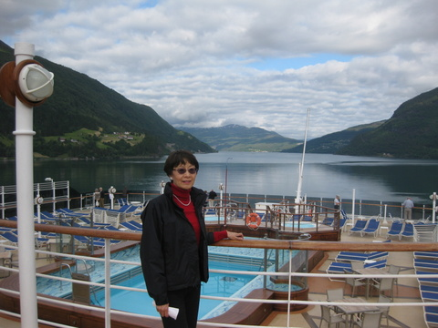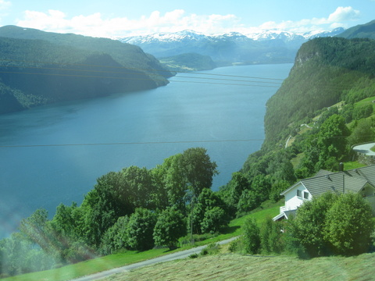  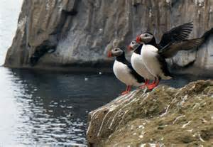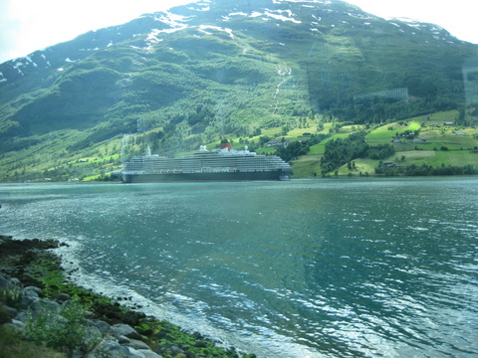  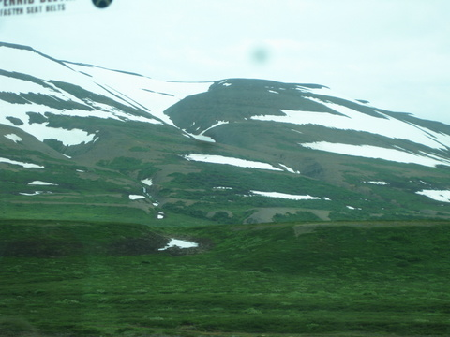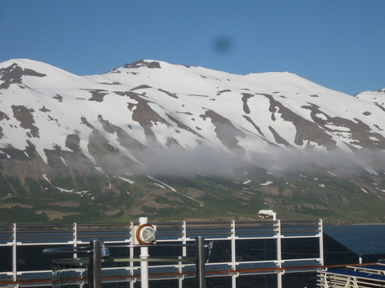  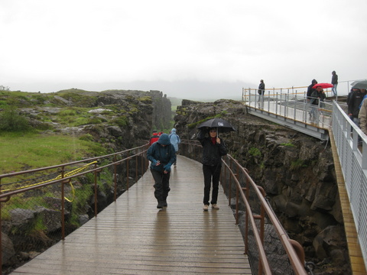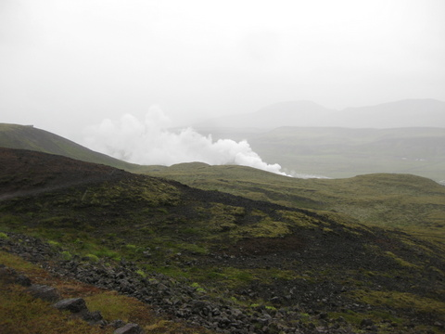  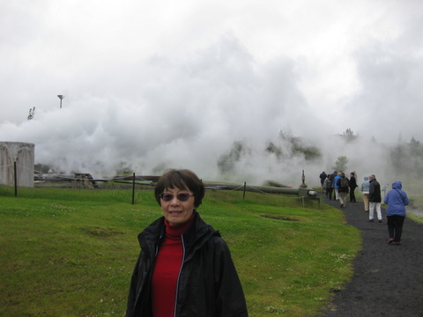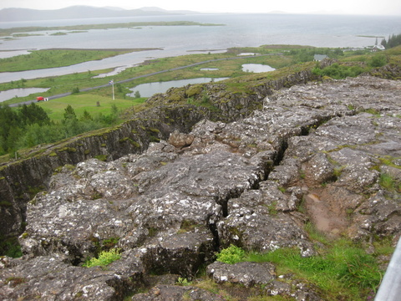 | The Norwegian seascape assumes the dimensions and briskness of the sky which meets the towering mountain dotted with glacier patches overlooking glassy fjords. The vast space echoes the sounds of tranquility and eternity. As the summer sun prowls in the horizon without rise or set, its endless rays redefine the abstraction of time. The singing puffins puncture through the silence of the crisp air then dive into the water to feast on herrings. The scenic grandeur elaborates an artistic expression of nature's utmost serenity where one would sanctify one's spirituality.  Iceland surges out of the 2 tectonic plates venting its anger through steaming vapors and crying out voluminous jagged lava formations. The schizoid clash of arctic volcanic tundra and sporadic farm settlements allure spiritual apparitions of Trolls and Elves. The challenging topography and harsh weather have never devoured Icelanders' ingenuity in building modern conveniences: ring roads, geo-thermo power plants, green houses, etc. The raw beauty of this landscape fuses awe into its dreamy aura.
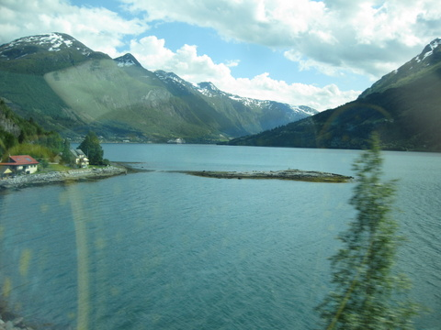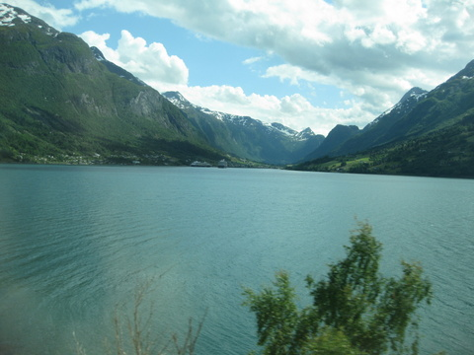  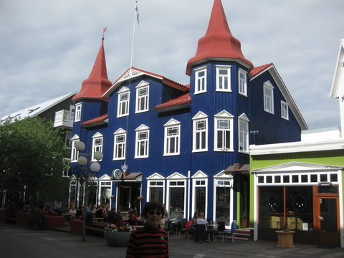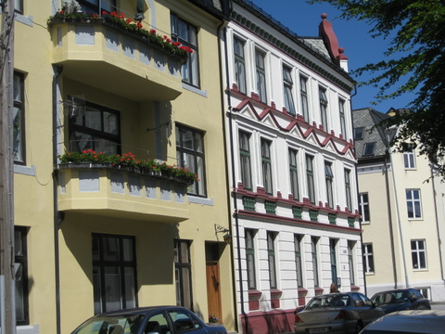  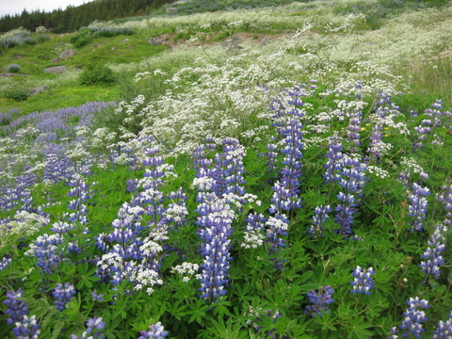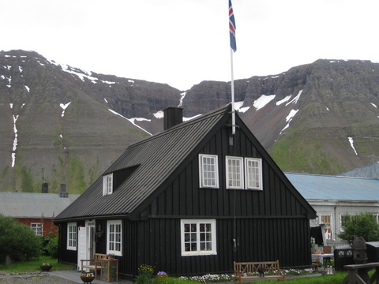  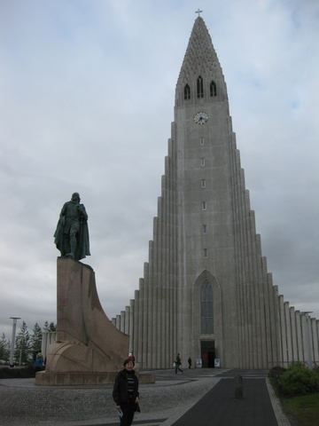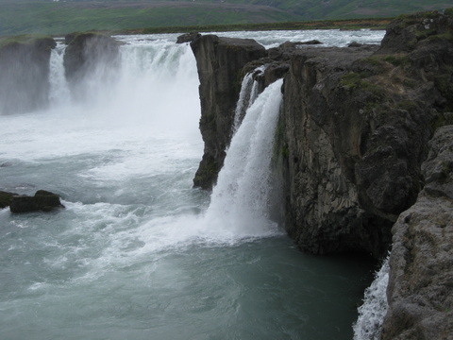  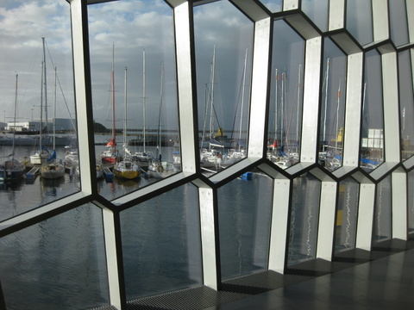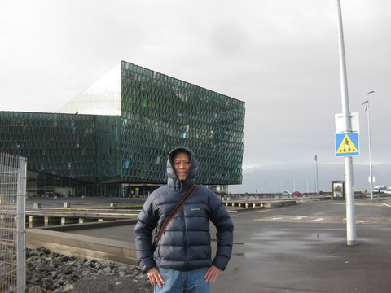 | Our Ports of Call:  - Nestling in Olden's (Norway) valley is its lengthy green fjord where a row of protruding rocks were mistaken as Russian submarines by Nazi who had bombed the fjord during WWII, what a preposterous assault to this charming surrounding. The neighboring lake, Hornindalsvatnet, is the deepest lake in Europe, where the silhouette of mountain peaks is reflected from the surface of its translucent water.  - However devastating the 1904 fire might be, determination and perseverance of Aalesund's townspeople could not be subdued. Aalesund (Norway) was rebuilt in the art nouveau style, and now a thriving port with absolute enchantment and beauty. The aerial view from Mt. Aksla adds deeper perspective of its colorful vividness. The world biggest bon fire is lit every summer in June to commemorate John the Baptist’s birth. Wood pallets are stacked over 131 ft high, and the bonfire can be sighted miles away.  - The thundering torrents of Godafoss waterfall at Akureyri, Iceland, conjured up images of the dramatic encounter of Christianity by Viking's Paganism. Visions of those pagan idols renounced in the torrents turned into a pageantry of triumph of their converted faith in Christ.  - Perhaps the most enchanting attraction of Isafjordur, Iceland, is the peace, quiet and endless tranquility. While the people here have waged battle against the elements of nature, acres of mountainside lupine fields in lavender have conquered the harsh terrain into secured grounds preventing mud slide.  - Reykjavik, the capital of Iceland, a charm that appeals to complex modern minds attracts urban living with rural tranquility. Geothermal power has transformed the city into a green paradise for young artists, musicians and professionals seeking vitality in life. Its well-known church resembling the lava flow in architecture conveys the Icelandic essence of spiritual significance. The paneled window of Harpa Concert Hall frames a live mural of the scenic harbor bathing in the mid-night sun.
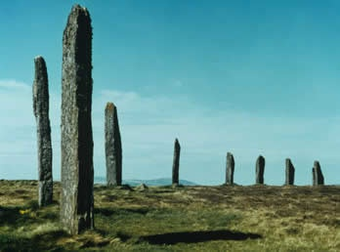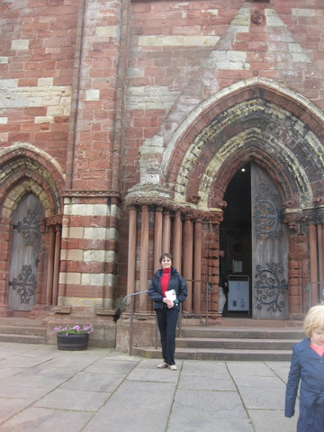  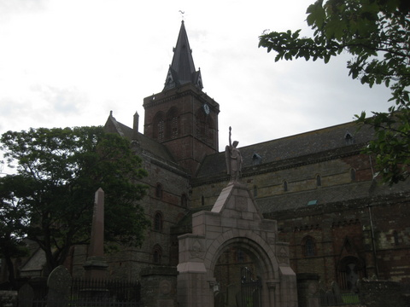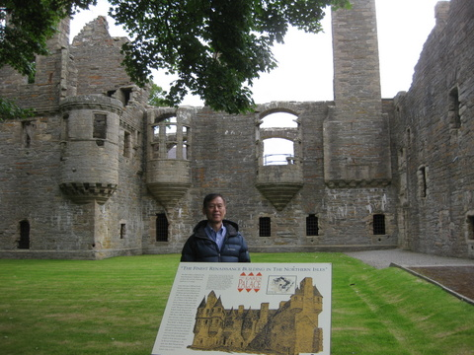  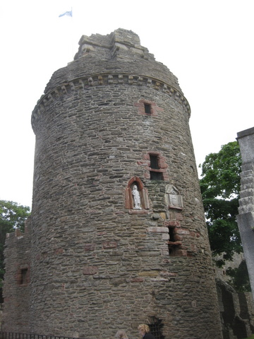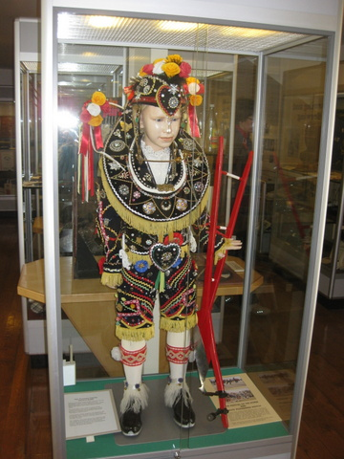  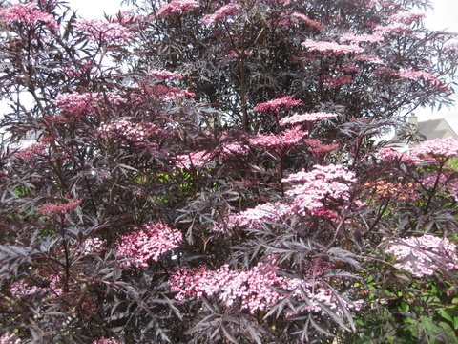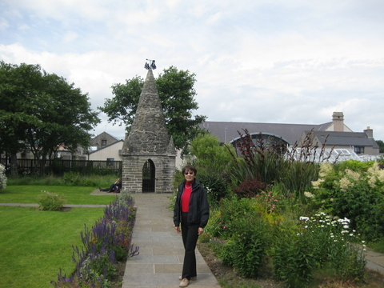  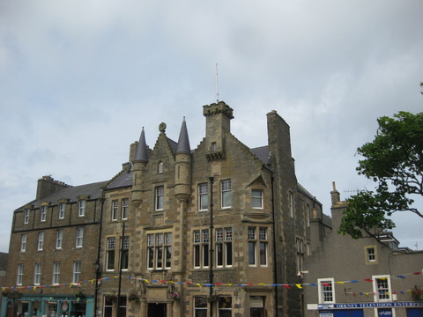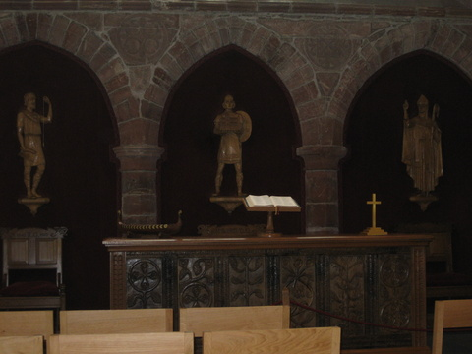 | Orkney Islands and Kirkwall:  Time has left its footprints on the Orkney Islands. The enigma of standing stones and circles throughout the archipelago entices visitors' curiosity. The Viking-built St. Magnus Cathedral in Kirkwall has been well preserved for more than 900 years, unscathed from the Reformation assaults as well as from many war fares.  Near the Cathedral, the Earl's palace, now a ruin, was the torture chamber of the Stewart Earls in the 17th century, who was seethed with destructive passion. In Orkney's winter when a black cloak of darkness covers the islands, the Orcadian people gathered around their fires to pass the long nights with songs and stories. The ruin of the Bishop's palace reminisces the vanishing magic of their folklores.  The Orkney Museum tells the story of Orkney, from the Stone Age, through the Vikings to the present day. Its beautiful garden and exotic plants and flowers are a feast for visitors' eyes.

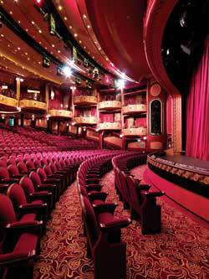 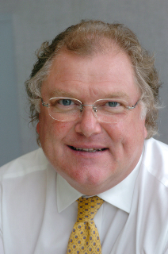 Lord Digby Jones  Minister of UK Trade & Investment  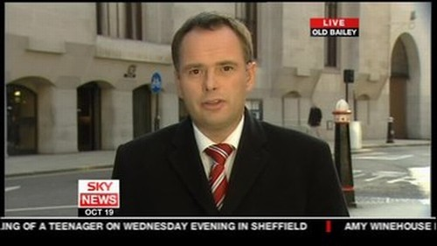 Derek Tedder  Sky News television correspondent & broadcast journalist  Dr. Andy Adam: Pathologist, Medical Scientist & Medical Historian  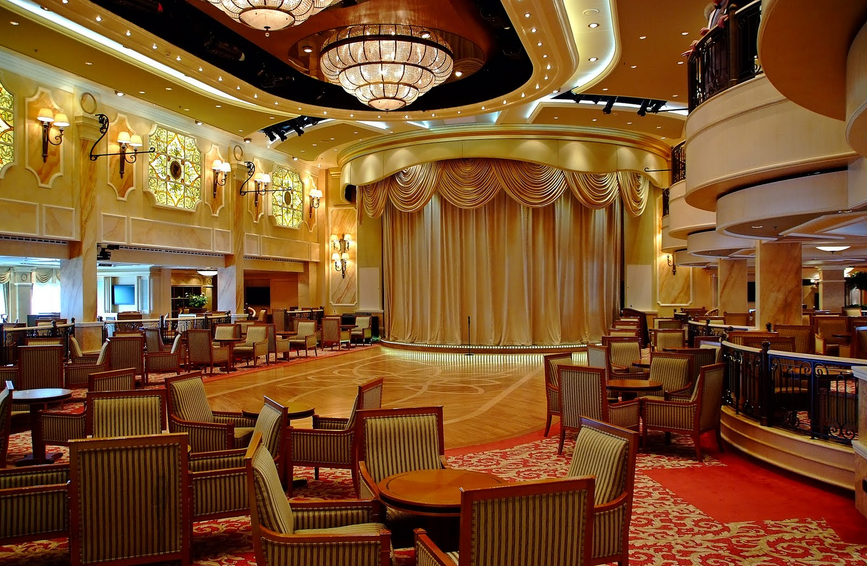 The Queens Room | Enrichment Programs:  To me, real traveling adventure is not necessarily about sensory enjoyment but about a journey of mind, i.e. learning. Cunard's Insight lectures on board certainly stimulated travelers' minds.  Lectures for mind enrichment covered:  - Journey to the House of Lords  - What Globalization means to You  - British Prime Ministers - Their Ups & Downs  - 2 Q&A Sessions By Lord Digby (full house and full standing room!)  - Behind the TV Scenes - Tricks of Green Screen  - Journalism - Ethics and Morals  - Experience of Covering Major Murder Cases  - How to Use TV Production Techniques to Create Home Videos  - Queen Victoria's Widowhood Without Prince Albert  - Humor in Medicine  - How Victorians Turned Murder into Entertainment  - 3000 Cases of Near Death Experiences  - Great English Eccentrics  In Queens Room, the formal balls, afternoon high teas, sequence dancing and concerts allow one to fancy the splendor of the Victorian era.

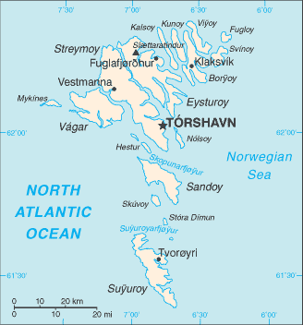 | Skipped Port:  The ocean swell was so severe that our ship could not possibly dock or anchor at Torshvn.  Torshvn of Faroe Islands was one of the highlight destinations during our cruise. We sailed through the rough currents along this self-governing archipelago under the control of Denmark.  To me, it is not necessarily regrettable having skipped this port. It might help me fade those notorious images of their whaling games and gruesome traditional dolphin massacres in Faroe Islands!

