伊斯坦堡 梁崇正作
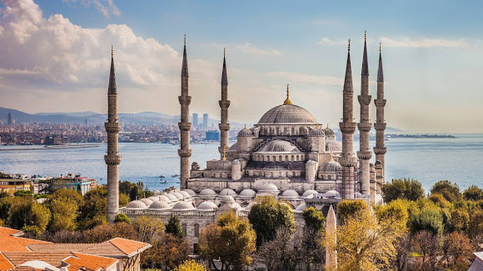

瑪爾瑪拉海的綠面紗
微微起皺 烏髮的女子
把守這歐亞間的隘道
挑揀攜來的珠寶和香料

下凡的諸神無心拋置
火種釀成巨災 雪亮的彎刀
槓上十字架 血花飛濺
染紅了拜佔庭的愛琴海

她撥弦輕唱 眼瞳飄浮著
鄂圖曼的煙雲 而黑海冰寒
如淚水盪漾 風聲唏噓
數落史籍上的哀怨

四月裡 春已為夏暖身
整容後的蘇菲亞教堂
以比羅馬更希臘的眼神
瞅視對街的藍色清真寺

註﹕伊斯坦堡環抱瑪爾瑪拉海，扼守歐亞間的捷徑，和地中海
通往黑海的水道，為歷史上東西方商業文化和宗教交流的重鎮。

北美華文作家協會2014.7

Istanbul 張彬彬譯 2018.3

The green niqab of the Marmara Sea, her gentle ripples
Unveiled the black-haired goddess and released her rules.
Guarding the Eurasian water narrowness.
She levied jewels and spices depending on her choices.

Earthly gods never intended to sit idle.
Catastrophic fire was rekindled.
Crusades crosses, shinning Muslim's sickles,
Splashed blood and dyed the Byzantine's Aegean Sea in red purple.

Chant on her strings, apparition floating before her eyes,
The fuming cloud of Ottoman' callings, the chilling Black Sea's ice,
Incite teardrop's rippling and wind's sobbing hiss
Counting down chronicle recordings, lamenting the sorrow grievances.

In April, spring has warmed up to welcome the summer.
Refaced Hagia Sophia with her enduring appeal
Embodies more Greek than Rome's wonders
Detesting the adjacent Blue Mosque despite Sultan's squeal!

