突圍 梁崇正

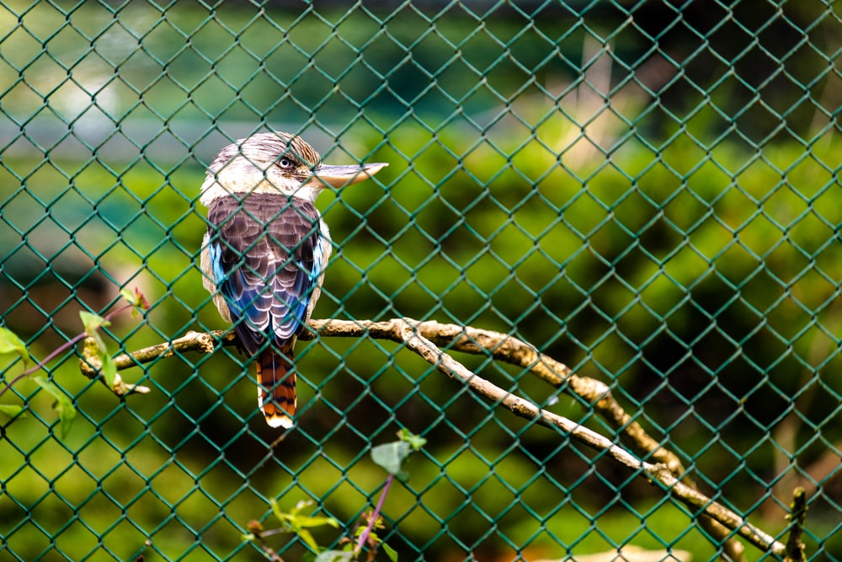
激昂的呼喊驚醒天邊的彎月
昨夜星圖預示層層的圍合
喧嚷的蒙面人潮川流不息
紅藍旗幟揮舞 難辨黑白是非
是左或右？ 抗爭或反抗爭？
當石塊警棍如雨下 誰能理會
民主或共和 正義和公理
那隔窗的永別和作勢的擁抱
缺氧的鮮花在封城鎖國裡枯萎
漫天鴉啼枯坐愁城 如此困頓
整裝待發 我尚不知奔往何方

2020.10

十二月 梁崇正

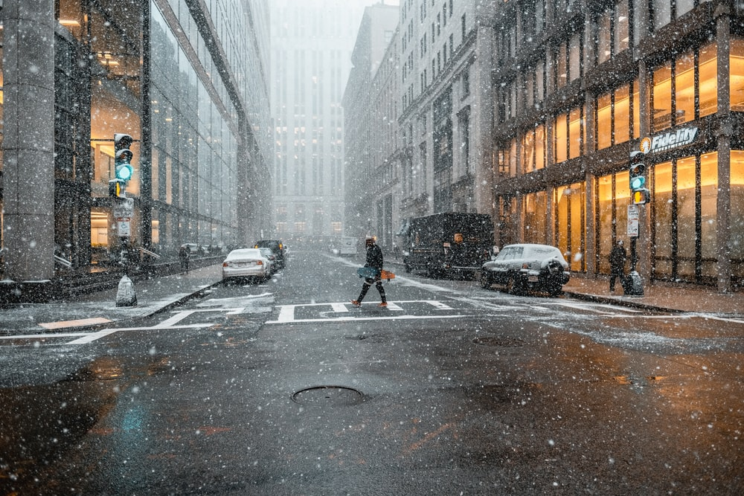

最短的日照 最冷的日子
令人思念慵懶炎炎的夏天

秋季豐收金黃色的糧草
保證充裕溫暖 度過這寒冬

掛曆翻到末尾 日子即臨盡頭
盼望鳥語花香春天的來臨

蒐集了滿山遍野繽紛楓色
是年終慶節的最佳飾物

2020.11

――――――――――――――――――――――――――――――――――――――
December Breakout

Bing Chang - 11/14/2020
(Resonant With Mr. John Liang's 2 Poems:十二月 and突圍)

December, the shortest sunshine, the coming coldest days
America, shrouded in broken leadership in the darkest haze

The raging virus, the death knell rings out expired souls.
In a divided nation, ballots are counted under red and blue poles.

The outbreak of the second wave in helpless ways
Looking ahead with a tearful gaze seeking sunshine rays

☆ ☆ ☆ More thoughts: ☆ ☆ ☆

The serpent said to Eve: “Did God really say, ‘You must not eat from any tree in the garden’?”
Implanting doubt, a credulous mind became confounded for certain.

If a conspiracy theory meets the heart's desire, it becomes the truth of sincerity.
The truth then becomes a belief, and the belief becomes a conviction of polarity.

The self-interest shysters then justify its validity
The false teaching preachers then sanctify its Biblical nobility

The horde finds an outlet for their deep-seated biases.
The fanned resentments permeate harmful viruses.

