Experience on Controlling Glucose for a Diabetic
Yuh-hwang Tsao 曹裕璜, 2015 in Houston

Summary
My experience of controlling blood glucose level without taking medicine is consistent with the common knowledge - the best way to control blood glucose level is through diet and exercise. From my experience, through many glucose tests on myself, I have learned some specific practices that seem to work for me. Those practices are keys to glucose control because they would tell you how much exercise, what food to eat, when to eat and exercise, and how to balance food and exercise.
The most important thing for controlling blood glucose level is to test yourself. Because everybody are different, you need to develop your own specific practices. This article includes how I have tested myself and test results. Below are lists of the specific practices I learned from my tests.
1. Modest exercise could significantly reduce glucose level. This modest exercise could be anything as long as it burns more than 40-50 calories, such as 10 minutes of jumping jacks or 30 minutes of yard/house work.
2. It is desirable to do such exercise about one to 1-1/2 hours after a meal. Exercise before meal does not appear to be helpful at all.
3. More exercise, say, 150 calories, might be needed after a heavy meal or a meal with high carbohydrates, especially ones with high Glycemic Index (GI).
4. It is important to exercise after dinner and to eat very little carbohydrates afterward. This would ensure low glucose level during the long period of overnight.
5. As expected, food with low carbohydrates are better than ones with high carbohydrates. The quantity of food are also important, especially for snacks. A snack with 15 grams or less carbohydrates is probably alright.
6. Exercise would be desirable even after eating only a small amount of sugar or similar food (e.g., rice, watermelon). It only takes 20 grams of sugar or rice to significantly increase glucose level. It is important to remember that total glucose in the blood of your whole body is less than 10 grams.
7. One way to control my glucose level is to eat less frequently. It's better to eat 2-3 full meals than to eat 5-6 small meals or snacks. In case you are hungry, eating less than 15 grams of carbohydrates is desirable. For example, 1 cup of nuts, a small/medium orange, a small banana.
8. Small adjustment of routine could have significant impact on glucose. For example, eating bread at the end of a meal and scheduling yard work/house cleaning after eating.
總結
我对控制血糖的經驗和一般的理論是相同的 - 血糖最好經由食物與運動來控制。但經过許多自我測試，找到了对自己最有效的方法。這些方法讓我知道什麼時候做運動，做多少，吃什麼，吃多少，和多常吃。
要控制血糖，最重要的是自我測試。每人体質不同，血糖問題的嚴重性也不同。要經过自我測試，才知最適合自身的食物與運動。自我測試，因為能得到自身的真实数具，也能增加对控制血糖的信心的持久性。 本文將提供我的自我測試經驗及結論，供大家參考。以下是總結。
1. 少量運動也可有效的減少血糖量。任何可用掉40-50 卡路里的運動均可。例如原地开合跳十分鐘，或做 30 分鐘家事/院子。
2. 最好飯後一到一個半小時後運動。飯前運動对降低血糖沒有幫助。可以在飯後安排做一些家事或其他體能活動。
3. 如果吃了許多碳水化合物，尤其是高 GI的，則必須要做更多的運動。例如用掉150 卡路里的運動。
4. 吃完晚飯後，必須運動。運動後要少吃碳水化合物。如此則在漫長的夜晚中血糖不会太高。
5. 含低碳水化合物的食物当然比含量高的食物好，但吃的份量也很重要。尤其在吃零食時要注意份量。 含 15 克以下碳水化合物的零食比較沒問題。
6. 即使只吃了少量的糖或類似的食物後，也最好做運動。只要吃了 20 克的糖或米飯就能明顯的增加血糖量，須知一個人全身血液中只含少於 10 克的血糖.
7. 少吃几餐也有助於控制血糖。一天只吃二、三頓要比一天吃五、六頓要好。如肚子餓，可吃含15 克以下碳水化合物的零食，如坚果加一個中型橘子，或一隻小香蕉。
8. 在日常生活上作一些調整，也可有降低血糖的功效。例如先把肉食，蔬菜吃了再吃飯或麵包，飯後做家事或院子。

I. Diabetes and Blood Sugar
At my physical in 2013, my A1C was measured as 6.8 mmol/l, or an "average" glucose level of about 150 mg/dl over the past three months. Depending on criteria, this was diabetic, or very close to diabetic. My family doctor wanted me to take glucose-reduction medicine immediately. I did not follow her advice because I wanted to control my blood glucose through diet/exercise before taking any medicine for the rest of my life.
As an engineer, I need to understand diabetes before I could figure out what to do. The blood sugar level is not a constant. It increases after a meal and then decreases with time and exercise. The following plot shows an example of changing blood sugar level with time for a healthy person after a full meal.
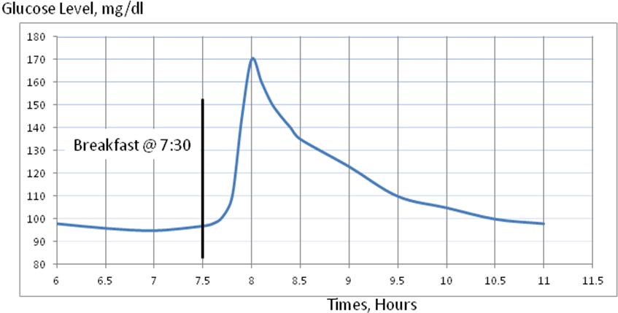
After a meal, carbohydrates break down to sugar (glucose) and is absorbed into blood, which increases the blood sugar level. How fast and how high the blood sugar level would change depend on the amount and type of food, as well as the functioning of your body, such as insulin. Insulin is a hormone produced by pancreas to reduce the blood glucose level. Refined sugar and simple carbohydrates are absorbed fast, in 15-30 minutes after eating. More complex carbohydrates would take longer time. In general, after a meal, blood sugar level peaks in less than an hour and then slowly decreases. The speed of increase in blood glucose level after consuming a food containing carbohydrate is called its Glycemic Index (GI) of that carbohydrate, with glucose at 100. The higher the GI, the faster the sugar is absorbed. Sugar, rice, flour, cereals with refined grains, some fruits all have relatively high GI. It is worth to know that there is no significant difference between white and brown rice.
How much sugar or rice would cause significant increase the blood glucose level? To get a quantitative sense, it is useful to know the total amount of sugar in a person's blood. A typical person may have less than 1.5 gallons of blood. For a blood glucose level at 120 mg/dl, total glucose in blood is:
120 mg/dl = 1.2 g/l, 1.5 gal = 5.7 liters, therefore, total glucose in blood = 1.2 x 5.7 = 6.8 g
Because enzymes modify glucose by adding phosphate or other groups to it, to maintain an influx of glucose into cells, there are more "sugar" in and close to our blood than actually measured by standard glucose test. In general, the total sugar in blood is less than 15-20 grams. This is less than half of the 39 grams of sugar in a 12-ounce can of regular Coke. Most of the sugar from carbohydrates we eat is eventually converted into glycogen, a polysaccharide, and stored in our muscles and liver. A typical person stores about 400 grams of glycogen in muscles and 100 grams of glycogen in liver. As each gram of sugar produces 3.87 calories, our body has stored about 2,000 calories of sugar/glycogen. Among these 2,000 calories, less than 80 calories are in the blood.

II. High Blood Sugar Damage Blood Vessels, Large and Small
It is well known that high blood glucose level lasting for an extended period would cause serious diseases, which include kidney disease, stroke, heart attacks, visual loss or blindness, poor circulation to the legs and feet, and poor wound healing. These problems occur because high blood glucose damages the blood vessels, especially the small blood vessels (microvasculature). All blood vessels have a single-layer inner lining of endothelial cells, called endothelium. This cell keeps blood flowing smoothly by producing local nitrous oxide (NO). NO serves to relax the smooth muscles in the walls of the vessels and prevent materials from sticking to the walls. With high blood glucose, the lining cells of blood vessels not only reduce their production of NO, they also increase the production of substances that constrict the blood vessel, cause further problems. If blood glucose levels have been high for a long time, the blood vessels could not relax or dilate.

Common cardiovascular problems such as stroke and heart disease could be made worse by diabetes due to damaging of the large blood vessels. More uniquely, diabetes also damage small blood vessels found in the eyes, kidneys and around nerves. Small-vessel disease is fairly specific for diabetes, while large-vessel disease also occurs in people without diabetes.

It is logical that the damage to blood vessels of diabetic patients could be reduced by either lowering the blood glucose level or shortening the duration of excessive glucose level. How high is too high and how long is too long? I could not find a consensus for guidance. The suggested onset of damage varies from a glucose level of 140 to 300. Regarding the effects of time, it appears that a couple hours of high blood glucose levels might not produce severe lasting effects or symptoms. However, it is important to note that very high blood sugar level (e.g., >350), even for a short period of time, could cause acute hyperglycemia, which might result to serious complications.

III. Practices to Control Blood Glucose Level
Everybody knows that blood glucose level could be controlled by eating correctly and exercising regularly. The key is how to do it effectively and efficiently. Extreme low carbohydrates diet could hurt our body and excessive exercise may not be sustainable for most people. In addition, the timing of eating and exercising could also be important.

We have to eat carbohydrates, even sugar sometimes. From previous discussions, we know that only a small amount of sugar stays in our blood. It does not take much sugar (carbohydrates) to significantly increase our blood glucose level. For example, three grams of extra sugar in our blood would increase the glucose level from 100 to 155. Since one slice of bread contains 35 grams of carbohydrates, one bite of bread might produce more than three grams of sugar. For a pre-diabetic person without an efficient functioning of insulin, even a few bites of bread or rice could cause some problems.

The good news is that the blood glucose level starts to reduce from its peak about an hour after a meal, as absorbed glucose from carbonates being converted into glycogen in muscles and liver. This process is repeated every time we eat carbohydrates. Therefore, a useful practice could be reducing the number of such cycles. In other words, we could limit the number of times we eat. We might need to eat only 3 meals or less a day without snacks. If we have to eat snack, low carbohydrate food, such as nuts, might be more desirable. In addition to low carbohydrate content, fat and protein in those foods slow the digestion of carbohydrates. Recently a researcher from Weill-Cornell Medical College found that eating bread toward the end of a meal instead of at the beginning reduced the peak blood glucose level by 30%.

Type-2 diabetics are often caused by insulin resistance of his cells. Insulin is a hormone produced by the pancreas, which promotes the absorption of glucose from the blood to muscles and fat tissue. It mobilizes and promotes glucose transporters to move glucose from blood to muscles. In addition, insulin also inhibits the production of glucose by the liver. When a person develops insulin resistance, he has less number and activity of glucose transporters in his cells.

Exercise improves the function of glucose transporter stimulated by insulin. More importantly, muscle contraction also stimulates glucose uptake and that the effects of insulin and contraction are additive. Therefore, a diabetic with insulin resistance could still have an effective pathway to remove glucose from blood. As indicated before, the energy stored in blood, as glucose, is a rather small amount. A typical person has less than 20 grams of glucose and related compounds stored in blood, which may provide 80 calories of energy. Anyone who pays attention to exercise knows that it is relative easy to burn 80 calories. Even in sitting and resting, we typically burn 0.5-1.0 calories per minute to keep our body functioning. We might only need to burn a portion of this 80 calories to significantly reduce our blood glucose level. Approximate calories burned with mild exercises for a 150 pounds person are listed in the table below. These numbers are not precise and they could vary depending on other factors, but the key point is that it is fairly easy to burn 40-50 calories above and beyond the 0.5-1.0 calories per minute required to keep our body functioning. For some people, especially the ones with pre-diabetics, this 40-50 calories might be enough for the need of significantly reducing their blood glucose level.

Exercise Calories

10 minutes walking at 2 mph | 30
Climbing 60 steps of stairs | 30
10 minutes walking at 3 mph | 40
Racking leaves for 20 minutes | 60
Gardening for 30 minutes | 60
Vacuuming/mopping house for 20 minutes | 70
Jumping jacks for 5 minutes | 70
Slow swimming for 15 minutes | 90
Lifting two 5# weights 10 times | 120
Mowing lawn for 20 minutes | 120
Golfing with walking for 45 minutes | 150

The calories burned can be added. For example, if you walk and lifting 5-pound weight at the same time, you are going to burn lots of calories. It needs to point out that people with severe diabetics (e.g., A1C > 8.0) might need more exercise to significantly reduce blood glucose level.

Exercise before a meal would not have much impact on the glucose level after the meal. After a meal, the blood glucose level usually reaches a peak and then slowly drops. This peak probably means that the adsorption of glucose from food is about equal to the removal of glucose from blood. It might be more beneficial to start exercise after this peak has reached. In general, this peak is reached within an hour after a meal. Consequentially, it might be desirable to start exercise an hour or more after a meal. Obviously it is still helpful to do a mild exercise (e.g. slow walking) right after a meal, but the same amount of exercise could be more beneficial if it occurs a little later.

IV. Are Those Glucose-Controlling Practices Applicable to Me?

Would those glucose-controlling practices discussed in the previous sections work for my body? An approach to this question is to measure my blood glucose level after eating a certain meal, with or without exercise. This is essential for anyone interested in learning from my experience, since each one of us could react very differently from various foods, eating habits and exercises. An effective practice for me might not work for you.

Before conducting those measurements, it might be useful to know my fasting glucose level. If my fasting glucose level is stable, it would provide a good reference point. Twenty-two fasting glucose level were measured under normal circumstance at home. The average was 106, with a standard deviation of 8. One additional fasting glucose level was measured after a two-week vacation on a cruise ship, with a value of 121. My fasting glucose level appears to be reasonably stable. It also confirmed again that I am pre-diabetic.

A. Effects of Food on Glucose Level

Type and quantity of food should have a big effect on glucose level. I conducted many measurements of glucose level, most were under normal living situation, not during "designed" experiments. Instead of often recommended 2 hours after a meal, many of my measurements were made 1.5 hours after a meal. One and a half hours would have passed the peak of glucose level but it is still high enough to better assessing the effect of food and exercise.

Since I ate banana often, seven measurements were made 1.5 hours after eating a banana, six times with a large banana and one time with a small banana. The average glucose level 1.5 hours after eating a large banana was 140, with a standard deviation of 9.1. The glucose level 1.5 hours after eating a small banana was 111. This 29 mg/dl difference is significant. The size of a small banana was about half of a large banana. A large banana may contains more than 30 grams of carbohydrates. Other measurements with different fruits are below.

1.5H after 1/3 cup raisin, cereal and nuts | 167
1.5H after 8 dried plums, cereal & nuts | 165
1.5H after very full meal of one large avocado/crackers/soup | 163
1.5H after two medium orange (~300 g) | 154
1.5H after 30 grapes | 145
1.5H after a large piece of watermelon | 138
1.5H after 4 dried plums, crackers, cheese, tomato, OJ | 140
1.5H after a large orange (~200 g) | 134
1.5H after a medium orange and some nuts | 119
1.5H after a medium orange (~150g) | 114
1H after 300 calories of nuts | 111

It appears that eating raisins, graphs or plums in significant quantity could increase the blood glucose level by more than 30. The high glucose measurement for avocado could be related to eating large amount of food, especially crackers. Glucose level caused by avocado itself would probably be lower. The results for eating oranges are interesting. It shows the effect of quantity of food. A medium orange has about 14 grams of carbohydrates, 21 grams for a large one, and 27 grams for a very large one. The 6-7 grams more carbohydrates increased the 1.5H glucose level by about 20. Nuts might be a good snack since it does not increase much of glucose level. It might be a good practice to eat some nuts with high carbohydrate snacks, such as fruits. These comments are based on limited data. It only provides a general guidance.

Glucose levels were also measured after various meals, as shown below. All measurements were conducted after a full meal, so the quantity of food were about the same. These measurements were not designed to test certain practice or theory, but they might add more understanding about the effects of food on glucose level.

1H after full dinner of chicken/bean curd/onion/carrot | 116
1.5H after same dinner | 93
1.5H after a very large bowl of oxtail soup | 96
1.5H after dinner of chick legs, veg, nuts, wine | 95
1.5H after diner of raw tuna/bean curd/vegetables/wine | 99
1.5H after cheese/8 crackers/tomato/nuts | 102
1.5H after some quinoa, lots of meat, veg | 114
1.5H after very full dinner of pork ribs and vegetables | 115
1.5H after lunch of turkey/crackers/tomato/egg | 115
1.5H after beef fajita, 1 tortilla, beans (no rice) |  | 120
1.5H after same beef fajita meal as above at a different day |  | 124
1.5H after dinner of turkey/vegetables/bean curd | 123
1.5H after dinner of pork neck and vegetables | 125
1.5H after breakfast of bread/cheese/tomato/nuts/orange juice | 134
1.5H after similar breakfast above plus a small cake | 157
1.5H after dinner at Chinese restaurant, one small bowl of rice | 138
1.5H after full meal of 1/2 bowl barley, soy products, veg | 141
1.5H after full meal of fish, cereal, nuts, and a large orange | 144
1.5H after lunch of Whataburger and fry | 160
1.5H after one full bowl quinoa, soy products, veg | 168
1.5H after lunch of a whole Chinese lunch box with rice | 180
1.5H after dinner of rice noodles and several egg rolls | 185

These data support the common knowledge that types of food significantly affect glucose level, as its 1.5H measurements varied from 93 to 185. These translate into A1C from 4.9 to 8 if those glucose level remain the same for three months. For foods contained smaller amount of carbohydrates, as the top twelve cases (first 2 rows are one case), the glucose levels were lower. Consuming more carbonates, as the last nine cases, the glucose levels were significantly higher. A small cake increased the glucose level from 134 to 157. The average of the top eleven cases was 109 and the average of the last nine cases was 159. The difference was quite significant. With data, it has been much easier for me to control my glucose level by selecting foods that would not cause excessively high glucose level. Even at a restaurant, we could stay at low-medium carbohydrates meal. In the table above, after eating at Mexican restaurant, my 1.5H glucose level was at a reasonable 124 by skipping rice and not eating extra tortillas.

B. Effects of Exercise on Glucose Level
Could a mild exercise reduce the blood glucose level? Even without any exercise, the glucose level would have reduced with time toward the fasting level. The effect of exercise is primarily to accelerate this reduction. To answer this question, I have measured my glucose level 1-1/2 hours after eating, with and without exercise. In all tests, the glucose levels were between 125-135 at 1-1/2 hours after eating. In the figure below, the two red lines represent two tests without any exercise and the blue line with data points represent a test with exercise starting at 1-1/2 hours after eating.

The exercise was a mild 50 jumping jacks, which was done in less than 10 minutes. As expected, the glucose did not reduce immediately after exercise. The benefit of this mild exercise was clearly demonstrated by the next three glucose measurements. It dropped from 135 to 109 in about 30 minutes.

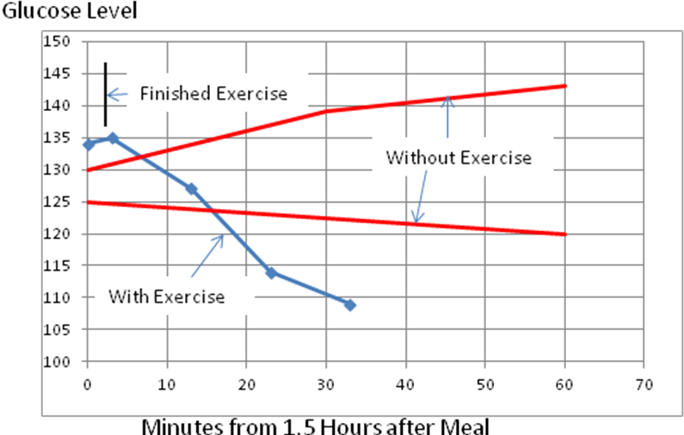

I was convinced that a mild and short exercise could significantly reduce the glucose level in blood. The obvious thing to do is to try different exercise with different foods. However, the time to measure glucose level after exercise and its interpretation could post a challenge. As shown by the blue line in the previous figure, it takes time for the effect of exercise to be measured correctly. This delay effect is because of the relatively long and varying time for the reduction of blood glucose around muscles to be transmitted to the finger tip, where the blood is used for measurement.

During exercise, the muscles use energy, which is stored in the form of glycogen, a polysaccharide. The glycogen burned by exercise will be resupplied by the glucose from blood. This is why exercise reduces the blood glucose level. To supply glucose from blood to muscles takes time, especially for a mild exercise. To measure the glucose level of the glucose-reduced blood, it has to be circulated through the capillaries of muscle to the capillary of the finger tip, which also takes time. The total time required for a representative glucose measurement after an exercise can vary with other factors, such as digestion and absorption of glucose from various foods, type and length of exercise, etc. It also can vary with individuals.

To better understand this time-delayed effect of glucose measurements after exercises, three tests were conducted with the same exercise, 50 jumping jacks, at 1-1/2 hours after the meal. The results are shown in the figure below, where glucose readings are plotted against time in minutes after exercise. The glucose levels were significantly different before exercise (at -3 minutes and -5 minutes) because I ate different foods. As expected, the glucose level did not drop much immediately after exercise. In general, it appears that it would take 10-30 minutes for the effects of exercise to be measured somewhat correctly. The time delay appears to increase with higher initial glucose level.

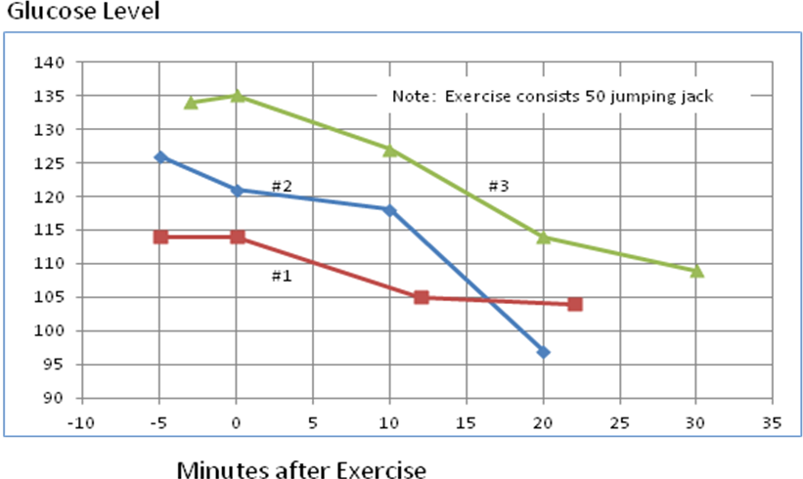

Since I had some confidence in measuring the effects of exercise. I conducted a series of tests, which consist of measuring glucose levels after eating a medium-carbohydrates meal and some exercises Those medium-carbohydrates meals were different but they usually include meat/fish, crackers, orange juice/fruit, chips, cereal or rice porridge. The glucose levels 1.5 hours after meal were around 125-145. The glucose levels after 2 hours without exercise probably would be in the range of 120 to 140. The amount of exercises varied, from 50 jumping jacks in less than 10 minutes to 30 minutes exercise of jumps and push-up. The times (e.g., 1.5H, 2H, 4H) of each item in the table was shortly ( <20 minutes) after exercise. The three cases after exercise of 50 jumping jack with short exercise time (less than 10 minutes) could have settled even lower if I had waited longer to measure the glucose. The important point here is that a mild exercise, such as a 10 minutes jumping jacks could significantly reduce the glucose level.

1.5H after medium carbohydrate meal, with 30m jump/walk/push-up | 81
2H after medium carbohydrate meal, with 50 min yard work | 93
2H after medium carbohydrate meal and 50 jumping jacks | 103
2H after medium carbohydrate meal and 50 jumping jacks | 104
4H after medium carbohydrate meal and 2 hours yard work | 96
2H after medium carbohydrate meal and 50 jumping jacks | 110

In the next set of cases, glucose levels were measured after a meal with more carbohydrates and some exercises. Those meals often include significant amount of rice, bread, or dessert. The exercises range from 15 minutes walking to one hour of treadmill at 3 miles/hour. One hour of treadmill burns more than 200 calories, or 50 grams of glucose. The results, again, support the practice of exercising after meal. One important conclusion of these data is that more exercise would be needed after eating significant amount of carbohydrates.

1.5H after sandwich & orange juice, with 20m bicycle | 112
1.5H after rice, meat and nuts, with 30m bicycle | 97
1.5H after high carbonate meal, with 30m bicycle | 108
1.5H after 1/2 bowl barley, soy products, veg, with 50 jumps | 121
1.5H after large banana, tomato/cheese/chip, with mild yard work | 122
1.5hr after tofu, beef, one bowl of rice, then walking 30m | 136
2H after cereal/banana/raisin/nuts and bicycle | 115
2H after high carbohydrate meal, with 20m bicycle | 113
3H after restaurant, 15m walking | 105
3H after restaurant with rice, small desert, 30m bicycle | 86
4H after large meal, 30m mild exercise | 102
4H after very full meat/vegetables/extra dessert and 1H treadmill | 100

One additional test was conducted to further confirm the beneficial effect of exercise. One hour after eating more than 50 grapes and 10 crackers, the glucose level was measured at 190. I rode a stationary bicycle exhaustedly for 25 minutes and the glucose level was reduced to 84, one and a half hours after eating. The calories burned was probably around 200.

The figure below illustrates in more detail regarding the effect of exercise to blood glucose level. I intentionally ate a large Chinese lunch box with lots of rice. Right before eating, my glucose level was 100. After finished eating and waiting 30 minutes, the glucose level increased to 212. Thirty more minutes after the meal, my glucose level increased to 263. Two and half hours after finishing the meal, my glucose level was dropped significantly, but to a still high 147. It took 3 sets of 50 jumping jacks each to reduce the glucose level to a "normal" value of 107. As previous data shown, for a meal with much lower carbohydrates, one 50 jumping exercise 1-1/2 hours later would reduce the glucose level to this "normal" level. This case gives us an idea that meal with high carbohydrates might need more exercise. It might be more desirable to start exercise 1-1/2 hours after the meal, which would reduce the exposure time of my body to high glucose level.

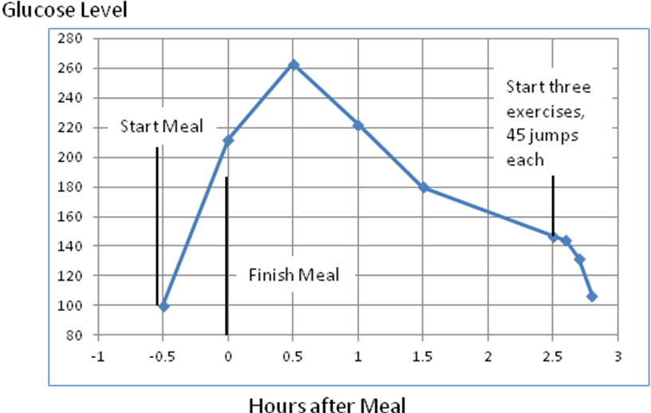

In the previous section, we have discussed that it might be desirable to start exercise an hour or more after a meal. The figure below shows two cases with different starting time. In both cases, a large piece of watermelon containing about 30 grams of carbohydrates, or 150 calories, was eaten. Most of the carbohydrates in watermelon are sugars. Thirty minutes after eating, the glucose levels were amazingly consistent for the two cases, at 161 and 158 respectively. In Case #2, exercises started immediately after the measurement and the glucose level after an exercise of 50 jumping jacks only reduced to 157 from 161. Two additional jumping jacks helped some but not much, with glucose level dropped only to 142. I probably should continue monitoring glucose to see if it could continue to drop significantly without further exercise. In Case #1, the exercise started 1-1/2 hours after finishing eating. The same three exercises reduced the glucose level to a "normal" 107. The results seem to suggest that a good time to start exercise might be 1-1/2 hours after a meal. Exercising 1-1/2 hours after a meal might also be beneficial because more blood could be used around stomach and gastrointestinal tract for digesting.
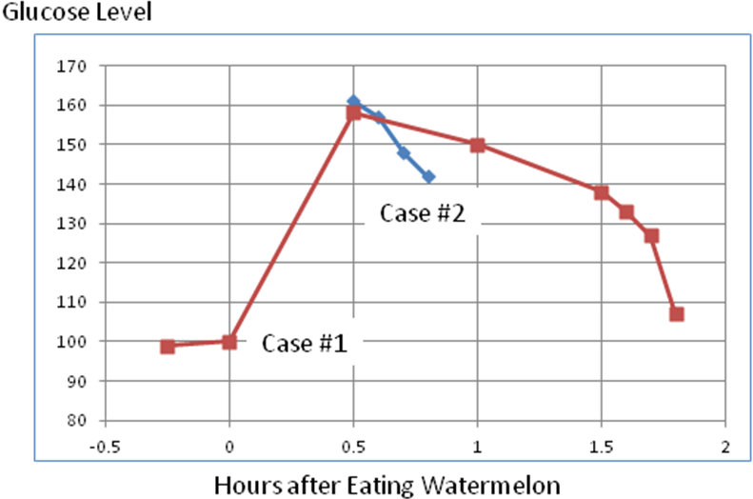
The practice of starting exercise 1-1/2 hours after a meal might also be reasonable considering our body's digestion system. After eating carbohydrates, the blood glucose level usually starts to increase after 15-20 minutes. The glucose level would continue to increase until an equilibrium is reached when the glucose absorbing into the blood is about the same as the glucose going out of the blood into muscles and liver. This equilibrium is the peak of the glucose level. For me, it probably occurs between 30 minutes to an hour after eating. Thirty minutes after finishing eating, the rate of absorption was still high. Some moderate exercises were helpful in reducing the glucose level much faster than without exercise (comparing Case #1 and Case #2 at 0.8 hour mark). Nevertheless, such moderate exercise after 30 minutes might not reduce the glucose level to a low enough level. Exercise is more effective after the glucose absorption rate is already much reduced, say, one or 1-1/2 hours after eating.
A more detailed illustration might further demonstrate the importance of mild exercise. The figure below shows my glucose level after meal and exercise in two cases. Meal #1 consists of one regular Whataburger and French fry. Meal #2 consists of a high carbohydrates meal at home with meat, crackers, soup, vegetables, and a small piece of cake. The exercise consists of 5-6 minutes jumping jacks (about 50 jumps). It appears that a brief exercise could significantly reduce blood glucose level. The difference between Meal #1 and Meal #2 could be the effect of French fry, which is very high in carbohydrates (about 50 grams, or 190 calories).

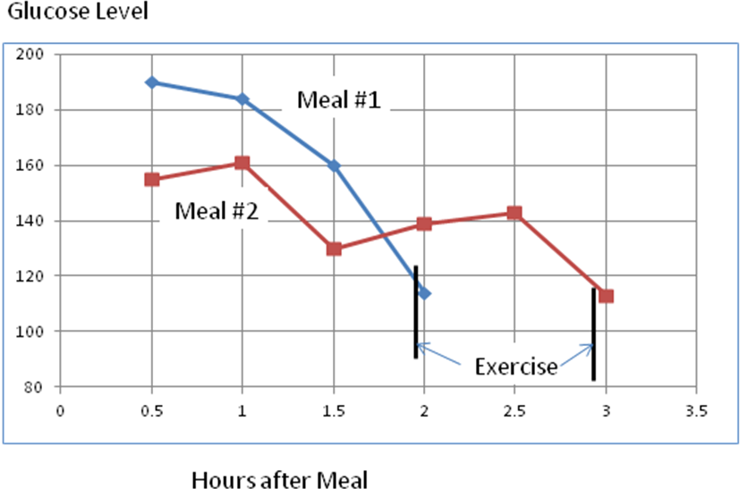

Another important issue is how often should we eat? My experience strongly suggests that the glucose level is easily increased even after eating a moderate amount of carbohydrates, such as a piece of fruit. After each eating with some carbohydrates, the glucose would go through another peak-reducing cycle. Each cycle could contribute to some damages by excessive glucose. It appears to me that the best practice is to eat fewer meals, followed by exercise. If a snack is needed, some low carbohydrates food, such as nuts, might be desirable.

